Lab 9 Draw Stars

Daniel Williamson

11/12/15

Section # 2

1. Restating the Problem

Given a text file with a stars coordinates and magnitude we need to use turtle to draw the location and size of the stars. We were required to read a text file and make dictionaries to hold the data extracted from the txt file. Also make a function to plot the size and coordinates of the stars. Here is a list of requirements from the lab.

* Open a text file a read its contents.
* Create a function to separate data into useable data structure.
* Create a function to draw with turtle using the txt file data.

1. Planning

I immediately knew that I need to make a function to read the text file and put it into a dictionary and a manageable form. After that I knew I had to make a function that will plot all the info that is now placed inside the dictionary. So planning was pretty straight forward. Make a function that reads the text file and splits/joins the data into a dictionary. Then I would have to make a function that reads the data from the dictionary and plots the stars by their coordinates and by their size of magnitude as instructed to do so.

1. Implementation

I started with making a function to put the txt file data into an actual useable form by splitting and joining the info into a dictionary. Once I had this data in a useable form I created the function to plot the stars without their magnitude calculated in to make it easier, I suppose. Once I was able to do that I recreated the function but this time with the magnitude of each star used. Once I had the final function working it was just a simple calling of the function to being the plotting of the stars.

1st picture – read_cords function that read and managed our data from the text file

2nd picture – the test to just plot the plain stars with no magnitude calculated in.

3rd picture – our final function to plot the stars by coordinates and magnitude intensity

4th picture – the lab9.py file being pep8 compliant

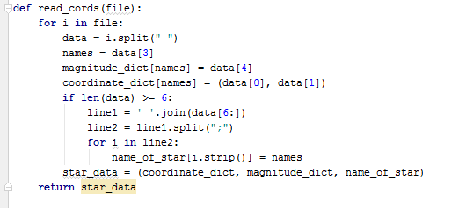

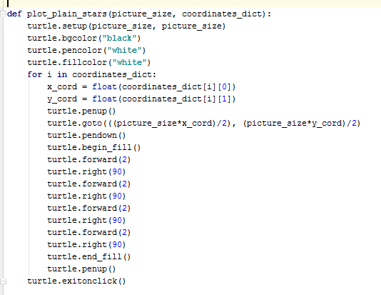

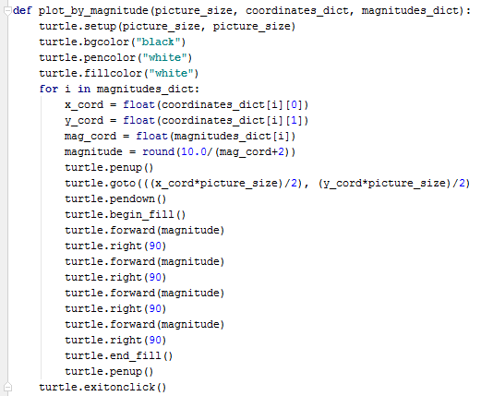

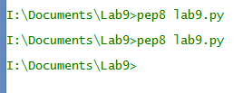

1. Reflection

This was a tough but short lab and there are many things i could have done to make the code more streamline. Better variable names. An example being the, for loops, I just used ‘i’ instead I could have used a better term. Maybe instead of making squares I actually made stars. That would be neat.